Guide
To install bundle -> go to bundle’s owner account (Commerce Solutions)
Desde ahi, "compartir" el bundle con la cuenta del cliente donde queres instalarlo:
Customization -> SuiteBundler -> Create Bundle -> List: look for punchout2go
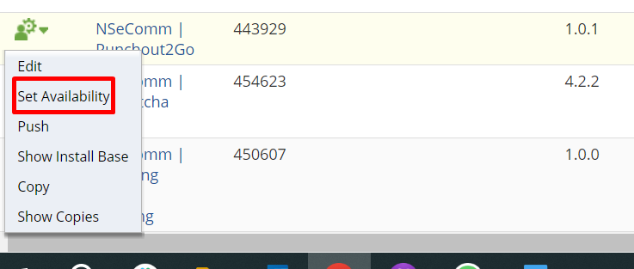
Press on “Set Availability”, then add netsuite’s account id on the box:
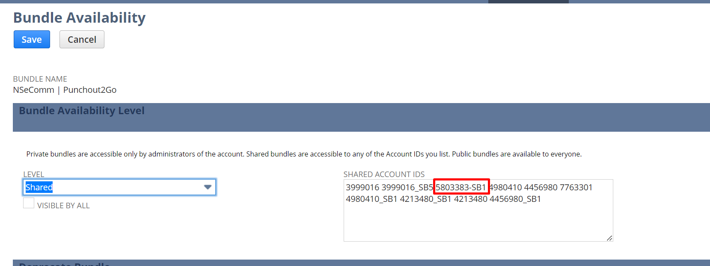
Then go to the client’s account, in this case ASUCLA:
Customization -> SuiteBundler -> Search & Install Bundles
And install the bundle

